The plan editor allows you to create a plan. We will explain how it looks and how to use the various components here. 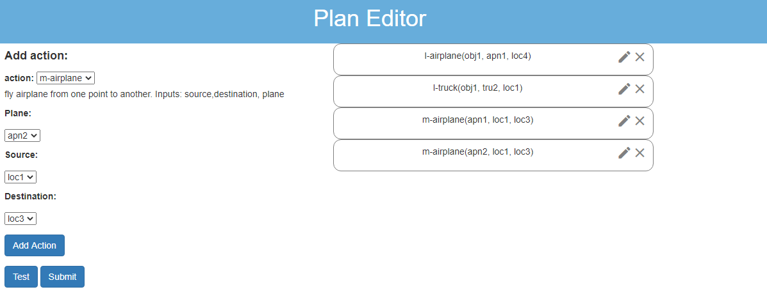

The first thing to do is to add an action. Selecting an action name from the drop-down menu displays the input parameters needed for that action.

Selecting these and clicking **Add Action** adds this action to the current **Plan**, shown on the right. The plan is executed from the **Start state** described previously, and steps are executed top-down. You can reorder the steps by clicking and dragging the white rectangles, and delete any step by clicking on the ‘X’ icon next to it.

You can also edit any action by clicking on the pencil icon. This brings up a window allowing you to modify the action and its parameters. Click **Save changes** to confirm any changes you make.

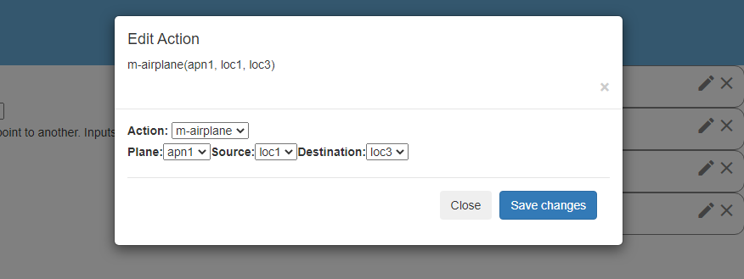

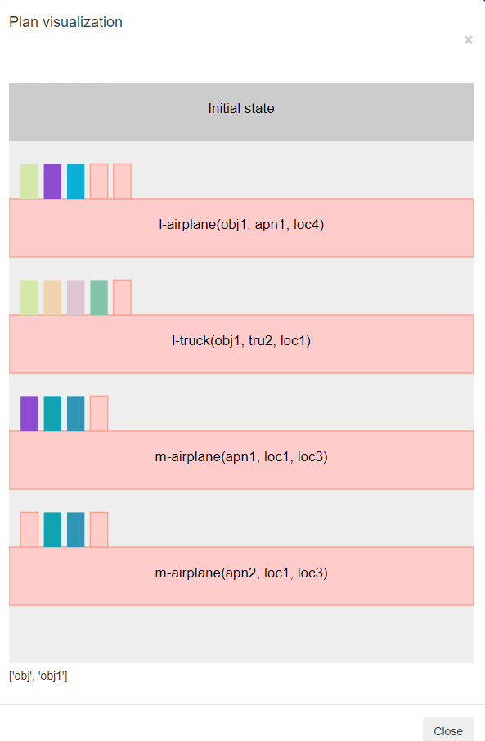The **Test** button opens up a visualization of the plan, showing you any possible issues, highlighted in red. You must ensure that there are no red highlighted areas and all plan steps are grey before submitting your answer.

The smaller rectangles on top of each step are the preconditions for each step, and hovering over them shows their description. The preconditions highlighted in red are the ones missing for the execution of that action. You must ensure all preconditions are satisfied for every action to ensure your plan is valid.

Once you are sure your plan achieves the goal state and does not contain any errors, you may click **Submit** to proceed.